1. Found installation guide for Wordpress: [https://ubuntu.com/tutorials/install-and-configure-wordpress#5-configure-database](https://ubuntu.com/tutorials/install-and-configure-wordpress%235-configure-database)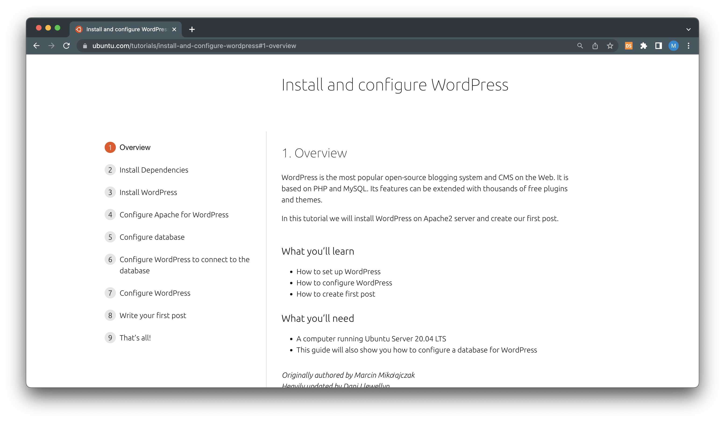
2. Made a Dockerfile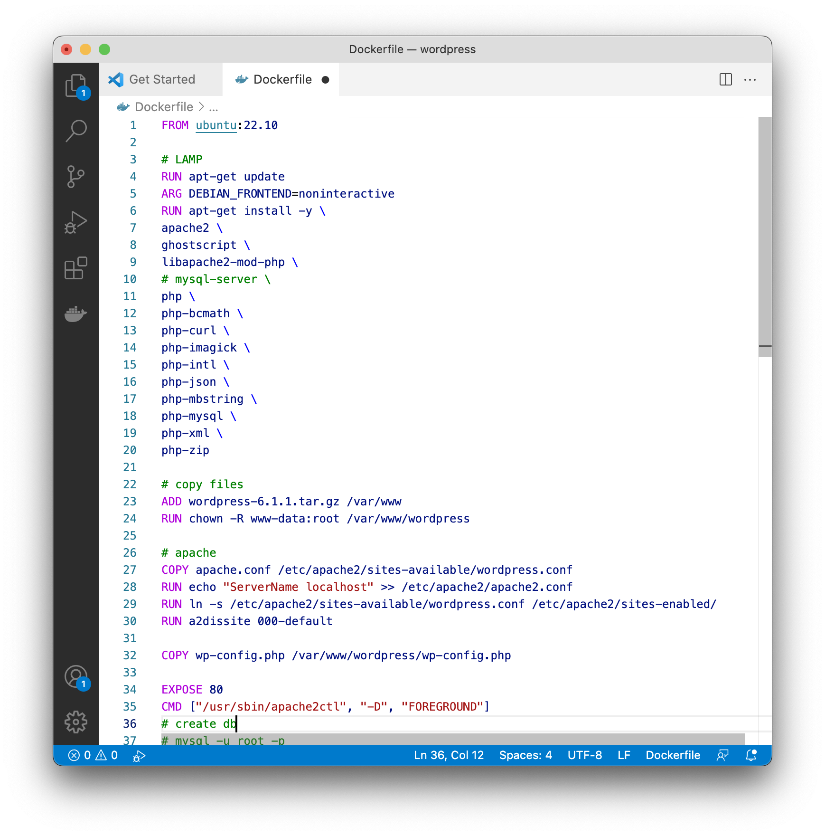
3. Prepared config files for apache and MySQL
4. Made docker-compose 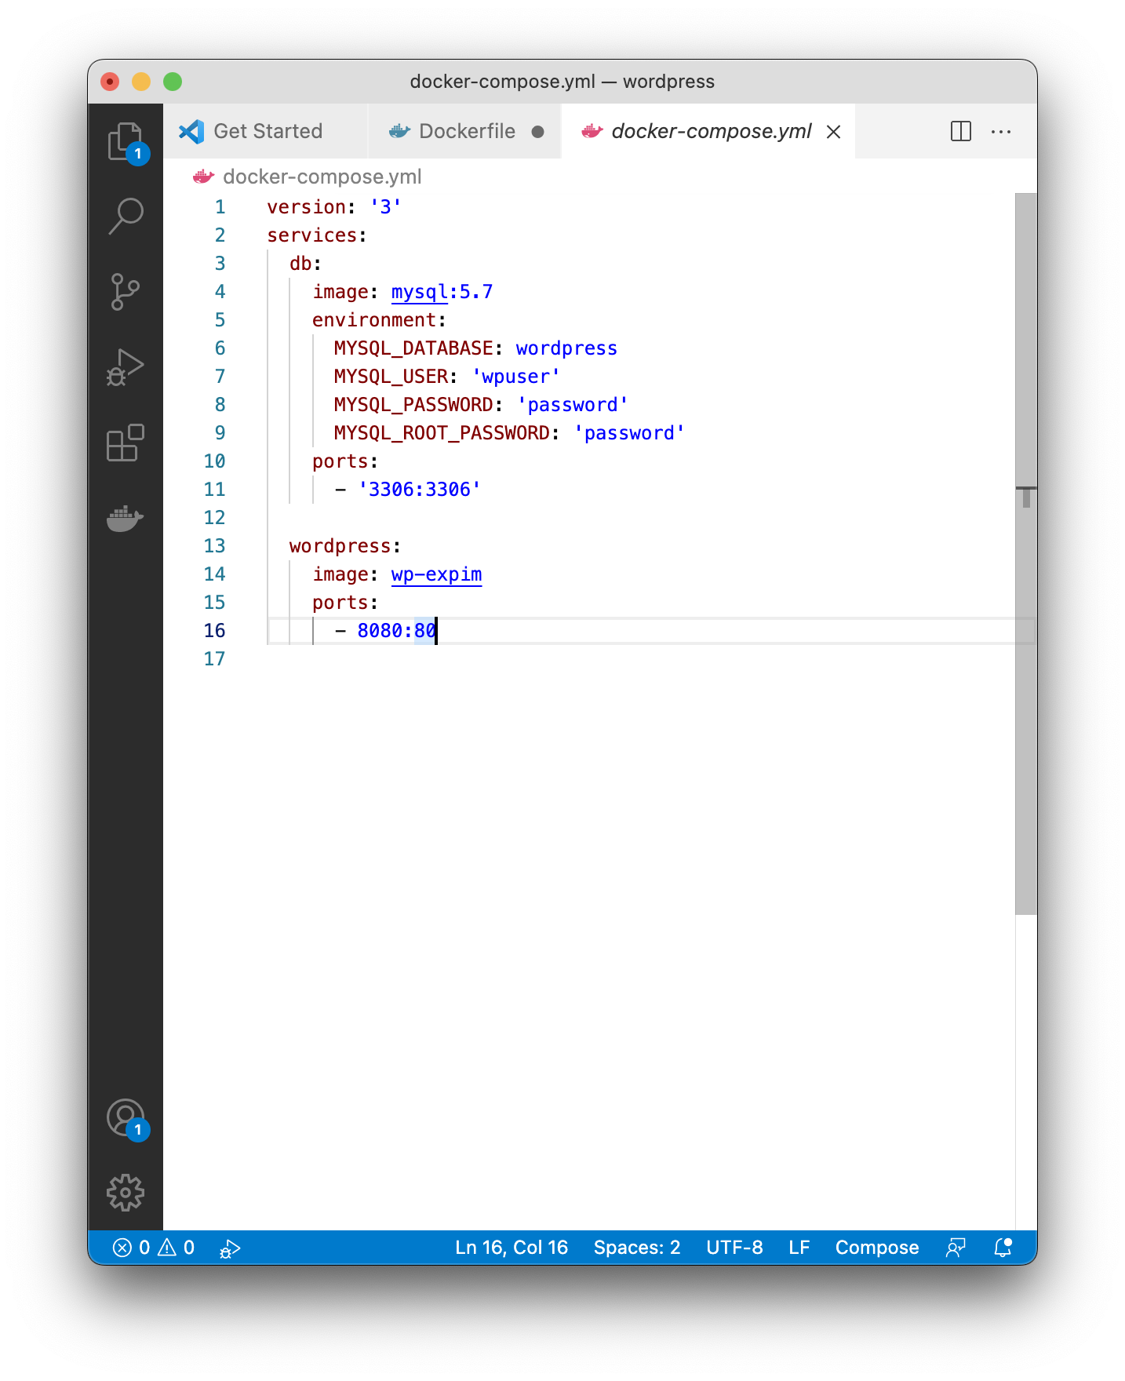
5. Hours of testing and fixing :)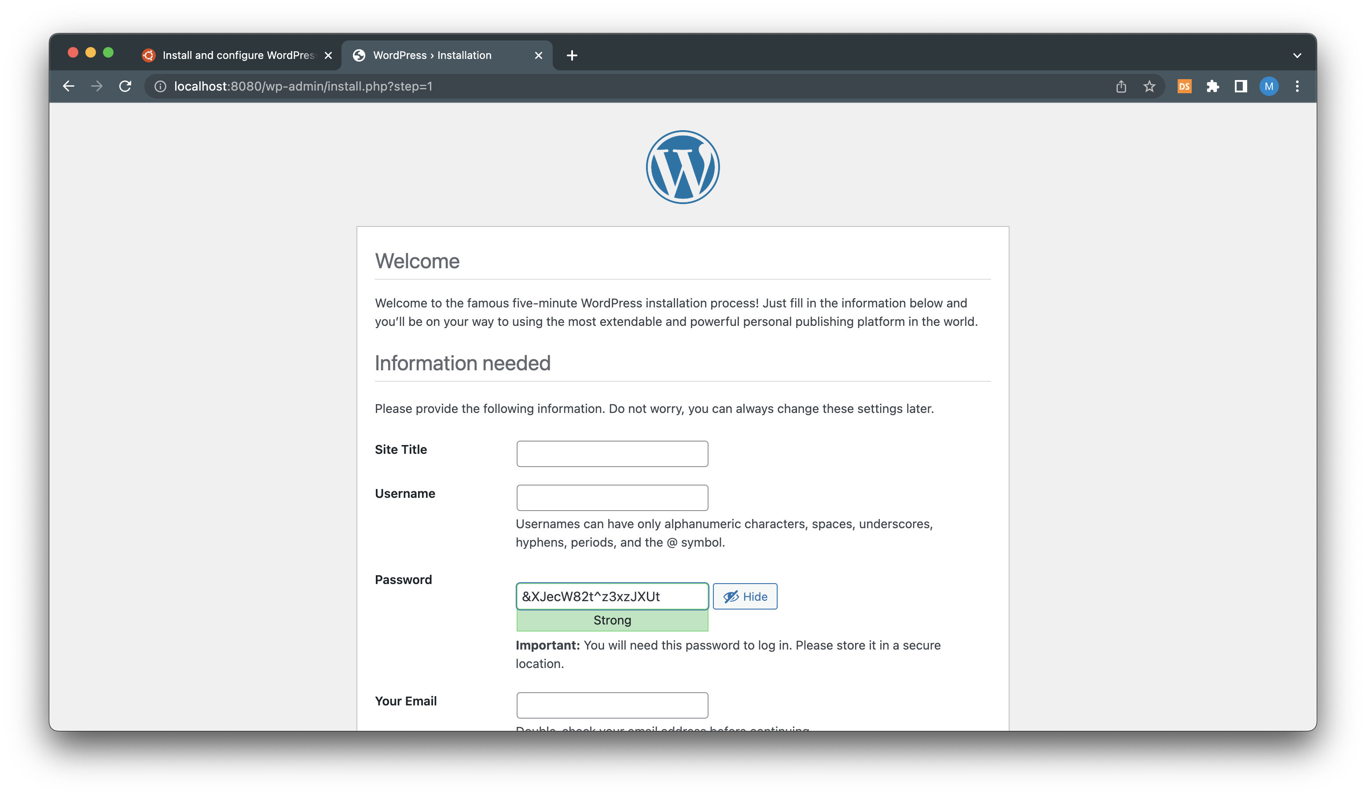

6. It works

